Software documentation
Ask Blommaert

This document will explain the technical workings of the installation in a more detailed manner.
The purpose of this document is to get our succeeding GLOW team up to speed with the codebase, and to inform them of the work that still must be done.
Link to the codebase: https://github.com/Ask1mo/ROLF

ROLF
That’s the name of the codebase. It stands for “Responsive Oracular Light Fixture”.
It’s the name of one of Ask’s old classmates who sadly passed away on the 11th of January this year. Rolf was an incredibly talented student. He helped me out a great deal with a little LED project of mine. Without his help, it would have never been made.
Little did I know at the time that I’d still be using that project. Little did I know it would be at the heart of this Glow installation. It felt fitting to name this codebase in his honor. Without him, this installation could never have been made.

Contents
System functions 4
Modular System VS Direct System 4
Self-discovery 5
Microcontroller: (ESP32) 6
Communications 6
OTA 8
LED control (Trinity) 9
Master 9
Todo list 10
Hardware comms instead of Wi-Fi 10
Persistence of connection 10
Horn color matching 10
Add LEDs to horns 10
Transmission reliability 10
Double retransmission prevention 11
Ignore unparsable transmissions (or their messages). 11
Audio triggering 12
Presence detection 12
LedSyncPulse 12
Document pins on PCB 12
Fix self-discovery 12
Implement predefined placements Backup plan 12
Rotate heart module in rotate() 13
Fix 3D self-discovering map 13
Master asks Modules for full connection. 13
Remove Modules from map 13
Map size dynamic allocation 13
Better OTA 13
Remote commands 14

System functions
This chapter will describe the functioning of the entire system.
We decided to create a full implementation of the software. The technology and its components will be the same as production. We made this decision based on:
- Our system would be technologically complex. With the likelihood of our succeeding team not containing a ICT specialist, we were tasked with fully implementing production code.
- Our prototype will only contain a small portion of the production system. We’ll be developing every aspect of the system but only in a small quantity. We’re able to do this because the system is scalable. The succeeding team will only mass produce our components to scale up the system.
Not all deadlines were met, and not all components were finished. These are described in the Todo part of this document.

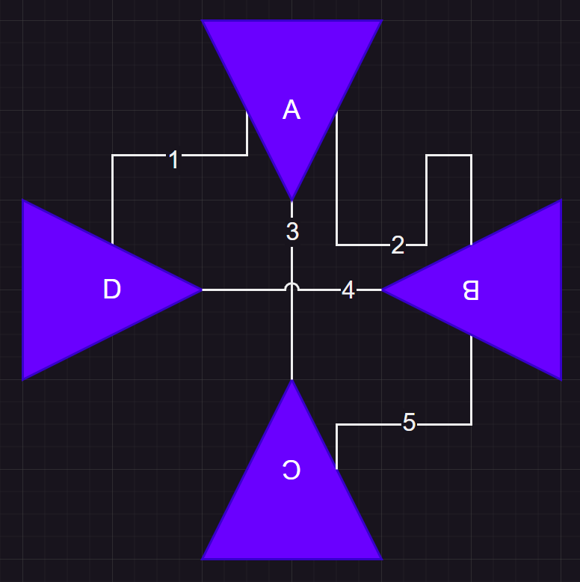
Modular System VS Direct System
Direct
The alternative is to connect multiple LED-strips to- and from every horn. This would mean that every connection made from a horn to the other would require its own specific LED-strip. So, if horn A is connected to B, C and D. It would require 3 led strips coming from horn A. If horn B is also connected to C & D: We would need another 2 led strips. Bringing us up to 5 LED strips that would have to be routed for only 2 horns.
We chose against this because:
- We want multiple routes to be possible from each horn to another. We don’t want horn A to be connected only to horn C. And B only connected to horn F. We want horns to be able to connect to multiple other horns.
- We want only 1 LED-strip to go through each pipe. LED strips are expensive, and the costs will rise incredibly quickly.
- Having multiple led strips will also require a pre-planned setup: strips will have to be measured to the exact correct length for every specific connection.
- Power management will be more difficult. LED-strips have a typical limit of 5m without voltage injection.
- Idle animations will be more difficult. With multiple strips going through every single pipe, it’ll be hard to create nice looking effects.
- Setup & repairs are significantly more difficult. Having to stuff multiple LED-strips running both ways through every pipe (Possibly round 3, up to 5) will be very difficult. If a connection fails, you’ll have to take apart possibly 5 meters or more of pipe and leds to replace the strip.
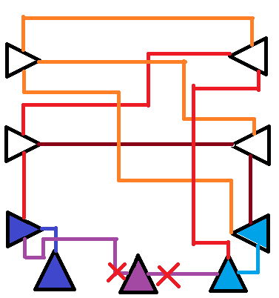
Besides these points, there’s also the problem of capacity: Since every horn is only connected to 1 to 3 neighbors, this will have capacity limits. This will occur when you’re talking into a horn that’s connected to neighbors that are already receiving messages from other horns. Example picture below.

In the picture to the right, you see a setup of 9 horns. White horns are not being used. The left 2 blue horns and the right 2 blue horns are talking to each other. The middle purple horn is only connected to the blue horns, but they are occupied with talking to each other, so, they are unavailable. This even though there are still 4 perfectly good available horns ready for use. To fix these problems we have chosen for the modular system:

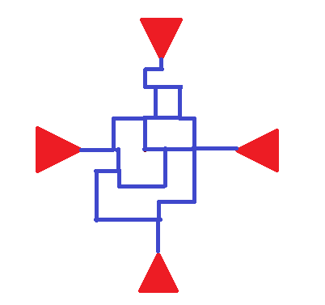
Modular
We want every pipe module to have its own microcontroller. It will communicate with all other modules to coordinate light and sound. While this is more difficult to code, we chose for this setup because of these benefits:
- Less LED-strips required.
- System can be scaled up significantly. (Limit not known)
- Light can take an infinite number of paths to traverse through the network which looks better.
- Light paths can be significantly longer. Theoretically as long as the entire pipe network.
- There is no pre-coding required for each specific setup of the whole system. The system is not limited to a single shape.
- Redundancy: If a module fails it will be skipped or avoided when pathing light. Broken modules can be replaced or even ignored in software: You won’t lose functionality when a module goes down.

Self-discovery
The modules will have to communicate with each other to create a map of all modules (mapping done in master controller). With this map it’s possible to route lights through the network. To create this map, we need information that every module gathers.
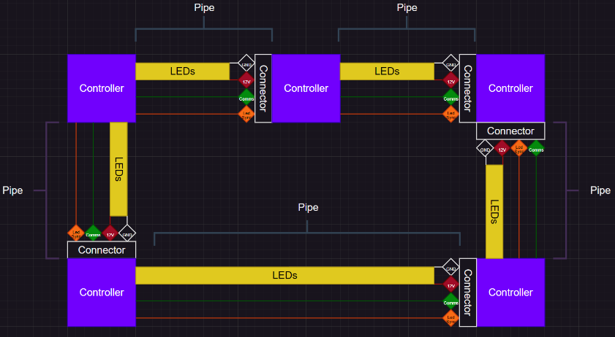
Modules contain a connector on every direction (North, East, South, West, Up, Down). Every connector consists of a “Comms pin”, “LedSync pin”, and a GND and 12v coming from the LEDs. (See picture on the right)
Modules will communicate with their directly connected neighbours through this “Comms pin”. They will exchange information about the connection they have with each other. The data collected contains:
- The module’s own MAC
- The direction on which the neighbor is connected to this module
- The MAC of the neighbor
- The direction on which the original module is connected on the neighbor’s side
Every module will gather this information on every direction. This information is then sent to the master. The master will use this data to construct a 3D map of all connected modules.

Microcontroller: (ESP32)
We needed microcontrollers to power the modules. We chose the ESP32 because the team’s software lead’s familiarity working with it among other reasons:
Specific board used: https://www.tinytronics.nl/en/development-boards/microcontroller-boards/with-wi-fi/esp32-d0wdq6-development-board-with-li-ion-li-po-charge-circuit
- Has WIFI capabilities (For easier development & OTA updates)
- Cheap enough (Cheapest devkit on TinyTronics)
- Has enough RAM to handle comms and LEDs
- Enough GPIO pins.
- Dual-Core & RTOS capabilities.
- High processing frequency needed for fast comms and LED printing.

Communications
The modules will have to communicate with each other. (More accurately: All modules will have to be able to communicate with the master, and back) We chose to implement a single wire UART (Serial) passthrough system. We considered these protocols:
- Wi-Fi: Unreliable. Incapable of managing 150 clients at once at high speed. (Theoretical expected number. Max 255)
- I2C: We chose against this protocol due to the low voltage on ESP32 modules (3.3V). Since our setup at one point had a theoretical size of 10x10m, voltage drops would render the protocol impossible to implement.
- CAN: Voltage drop may still prove to be unreliable at 12v. Hardware cost of adding CAN modules would exceed budget.
- Ethernet: Wiring & code complexity in combination with budgetary considerations.
- RS-485: May have been a good candidate. But due to unfamiliarity with the protocol we chose for UART.
- SPI: Communication would require a Chip select pin. (Pin that selects a Chip that will receive a transmission) This cannot be implemented in a modular system. While it’s fast, we decided it’s not worth all the wiring complexity. (4 pins on every direction instead of 1)

We chose for UART. With this we’d have a reasonably fast protocol. However, there were decisions to be made. UART is not a bus on which all modules are connected on the same time, and it does not inherently contain a “Chip select” functionality like the SPI protocol. To get around this, modules will have to be smart about managing transmissions.
- Transmissions will be passed over from one module to another. It’s a sort of repeater system.
- One-wire software UART is needed on all directions.
  - There isn’t enough Hardware UARTs for all directions (3 UARTs for 6 directions)
  - Software UART (If managed correctly) can be configured for 1 wire (Half duplex) transmission.
  - Half duplex is required since Full duplex on 6 simultaneous connections would be too complex to integrate with software Serial.
- Messages will need to contain information for who it’s meant to be read by. If it’s meant for another module, retransmit this message to your neighbours (Except the neighbour whom you received it from)
- Modules will have to check if transmissions have already been received before. If they do receive one that they already received before: Disregard it.
  - This means that the module/master that generate the transmission will have to include an ID in every transmission. If the combo of the original senderID and transmissionID are already read before: Ignore transmission.
There is no guarantee that transmissions with light instructions arrive at the same time on every module. To fix this we thought of an extra connection between modules. This extra pin will always remain HIGH.
When new LED instructions are sent out from the master, Modules will receive and store their LED effect instructions in a buffer. Then after a short time the power on this pin is pulled LOW (Modules retransmit this Pulldown to neighbouring modules). When the pin is detected as LOW, the instruction that was buffered will be played at the same time on all modules.
As an extra measure for reliability: 2 systems should be used to check if a message was successfully transmitted and received.
- Comms pin to busy: When a module is about to perform an action with a long duration, it sets all other pins to “Busy”: When a transmission normally starts, the Comms pin is pulled down to notify a neighbor that it has to pay attention since serial data is coming. With the softwareSerial you have to actively listen, it does not get buffered on hardware. After this pulldown a “transmissionTypeID” is sent. But for a “Busy” signal, no transmissionTypeID is sent. A neighbor will notice this signal and mark down this module as “Busy”. It will no longer send transmissions to it, and instead just buffer them. As soon as the pin is released and goes back to HIGH. All neighbours are free to resume tranmissions.
- Acknowledgements: When a transmission is successfully received, return an ACK. If no ack gets received, retransmit. There is no risk of instructions being parsed more than once due to the senderID and transmissionID checks (mentioned above). Once an ACK is received the transmission can be removed from a message buffer.

There are 4 categories of transmissions:
- Busy transmission: Technically not a transmission and has no data. But does inform a neighbor that this module is currently not available.
- PinTest transmission: This is the handshake that occurs between 2 neighboring modules to connect information about each other’s location relative to each other.
- Message transmission: These transmissions are re-transmittable. A transmission could contain a message. The term Transmission and Message are not interchangeable. Message transmissions contain:
  - GoalMac
  - OriginMac
  - messageID
  - message
  - messageType (not to be confused with transmissionType, This informs a module what kind of message they are about to receive. Required for parsing.
    - “TeReq” (Identification) The Master asking a Module what form of pipe module it is.
    - “NwClT” (Identification) A Module informing the master of what form of pipe module it is.
    - “UpReq” (Orientation) The Master asking a Module who it’s connected to.
    - “UpReq” (Orientation) A Module informing the master who its neighbours are and where they are relative to the module.
    - “HorTr” (Lighting) A Horn Module informing the master that someone’s talking into it.
    - “NewFX” (Lighting) The Master instructing a Module with new light effects.

OTA
An “Over The Air” update system has been implemented. This means no USB connections are required to update ESP32 firmware. To use it: Create a wifi network with the same credentials as noted in “Setup.h” (Or replace with your own). Then use the MAC address of the ESP in this format: “ESP_A0B7656C4740” (Without quotes). Put this under “upload_port” in your platform.ini file.

LED control (Trinity)
Another very important aspect is of course: lights. The software required as described above is already complex enough. Especially for a 1-man software team. Luckily, to save a lot of time we’ll be making use of the TrinityLED library. Its a private library/codebase/project that Ask has been working on previously. This library has many functionalities we could use in our project. We decided to implement a stripped-down version of this project as it implements the following:
(Note: Technically not a library)
- Has many effects and colours built-in.
- The library does a lot of memory management for you. So, no FastLED diode memory management is required.
- Adding grouped LED segments. Easy code for managing what LEDs are part of what LED tube.
- Easy application of complex effects per panel. (Or even per diode)
- LED timing control. You can control effect’s speed and add delays for starting effects at specific times.
These functionalities would all take a long time to implement from scratch. Combining this library with our project will speed things up significantly by not having to spend any time on LED code.
Master
The Pipe modules will be smart, but they won’t have access to the information required to perform pathfinding algorithms to guide the light from point A to point B. That will be the task of the Master.
To let a master communicate with the network, it’s also equipped with a directionalConnector to connect it with the UART passthrough network. The direction finding code is not relevant for the master. (Code copied from ROLF-Module to ROLF-Master for class uniformity between the 2 projects)
Interactions between modules and the master
First, when a Module comes online it will inform the master of its MAC (NwClT) and what form of pipe Module it is. But, if this transmission gets somehow lost there is a backup:
When the Master receives any kind of transmission from this horn whose identify(NwClT) transmission was lost, the Master will not recognize this module and will ask it to identify itself. (TeReq message Transmission)
Then, once a module has detected that it’s connected to a neighbour, it will inform the Master. (ConCh) The master also occasionally asks every module who they’re connected to. Just in case transmissions got lost. (UpReq)
Finally. Once a Module in the form of a horn knows someone is talking into it, It will inform the Master (HorTr). The Master will then select a horn on the network that is not occupied. It will then run a pathfinding algorithm through the network to trace a path. This path is then calculated into delay values which, combined with a colour, are sent as LED instructions to the modules on its path (NewFx). After a short delay it will trigger the LightSync pin which activates the new effect on all the modules at the exact same time.

Todo list
Below is a list of things required or that we recommend adding to the system. In no particular order.

Hardware comms instead of Wi-Fi
Problem: We used WiFi for communications. We used it for quicker development and debugging. This was used instead of the UART passthrough system this document describes. This system should be removed in favor of the UART passthrough system.

Persistence of connection
Problem: Every time you speak into a horn the connection will be randomized to a random horn. Even when people want to keep the conversation going
Goal: We want people to stay connected as long as they keep talking to each other.
Fix: Implement a system to keep horns connected to each other. The path tracing can/must still be random every time. But keep the Origin/Goal horn the same as long as they keep talking.

Horn color matching
Problem: Colors coming from horns are randomized
Fix: Implement system where specific horns will always have the color wave coming from them to be with the horn's corresponding color.
Example: Soundwaves coming from the "Red" horn must always have a red color.

Add LEDs to horns
Idea: We want to add more indicative elements on the horns.
Fix: We want to do this by adding a LED strip to the outside of the horn. This outside strip should show the colour of the horn. It should also show a sort of timer to show how much time you have left to record your voice message (We recommend about a 3 second recording window).

Transmission reliability
Problem: Communication over the Comms pin in the direcionalConnector class are unreliable. And are often incorrect.
Current: All transmitting should be done in the "pinTransmitV2()" function and all reading is done in the "waitAndRead()" function. These functions appear correct but still don't function correctly.
Fix: Find God and use him to fix my code
Note: There are delays used in transmissions. I tried to use them for debugging. Should be removed or at least shortened a lot in final implementation.
Observations 1 – Unexplained timeout in waitAndRead():
There have been issues getting serial transmissions to work. I’m using softwareSerial to read. This regards the PinTest transmissions
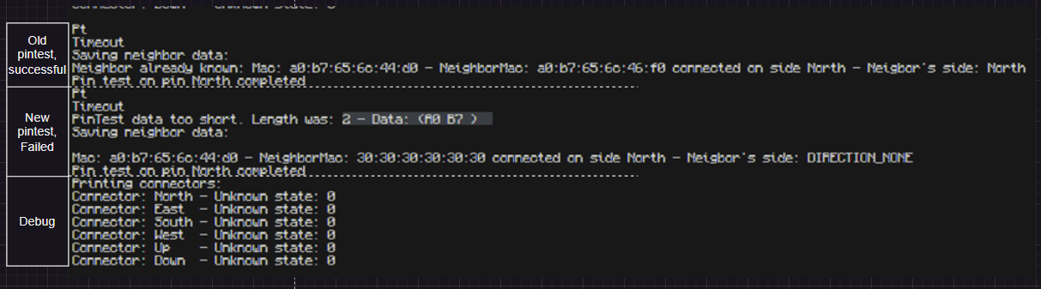
Above you can see the first pintest which was successful.
In the next segment you can see that (After the pintest identifier has been parsed) it started serialReading characters. Eventually the reading of characters timed out too early. You can see only 2 characters made it through: A0 and B7. These are part of the neighbor’s mac address which was contained in the message. But it weirdly timed out after 2 characters.
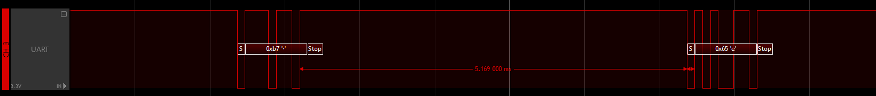
I checked the timings with a logic analyser. The timings are well within the specified duration of 10ms before the waitAndRead() function times out.
Observations 2 – Flipped bits in SoftwareSerial
There have been flipped bits in the same PinTest transmissions.
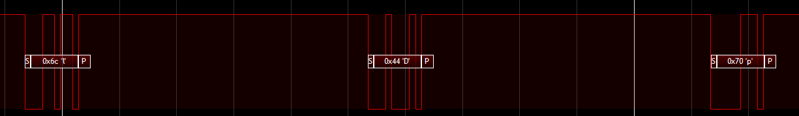
In the image above you can see the characters 6c, 44 and 70 being sent. These are part of a mac address: a0:b7:65:6c:46:f0. You can see that 6c was correct. But 46 has turned into 44.
These characters are represented as HEX. If we convert to binary you can see the 7th bit has flipped:
46: 0100 0110
44: 0100 0100
The same happened to f0:
f0: 1111 0000
70: 0111 0000
Conclusion
I’ve tried to fix this for a while. There’s nothing wrong with the timings as far as I can tell. I added a lot of temporary delays and millis() printing to make sure the timings are correct. There seems to be a problem with the SoftwareSerial itself. It seems to “Miss” transmissions, or even print out with occasional flipped bits. Maybe a problem with interrupts? (On the receive side)

Double retransmission prevention
Problem: Messages are just shouted around the network. The system to prevent transmissions that have already been received before from being retransmitted is not in place yet.
Fix: Let the connectorManager check if the message has already been transmitted by saving who sent it and it's messageID. Check these vars. If a message comes in to be retransmitted. Check if that message has already been sent.

Ignore unparsable transmissions (or their messages).
Problem: There is no real system in place to ignore broken messages

Audio triggering
Problem: We have no proper system in place to detect when someone is speaking into a horn. We’d prefer not to use hand calibrated sensors.

Presence detection
Problem: Goal horns are selected at random when someone talks into a horn. This will very likely often send their voices to a horn where no-one is standing behind.
Fix: We should implement a way to detect if someone is behind a horn. And only send audio waves to horns that have a person behind them.

LedSyncPulse
Problem: There may be speed differences in how quick LED instructions go from the master to all the modules. This will result in a badly synchronized LED effect between modules.
Fix: Store led instructions in a buffer. Load instructions from this buffer when a "Led Sync" pin gets pulled down. This LedSync pulse originates from the master, and is passed through the modules. When a module detect a pin pulldown, also pull down your own led Sync pins so the whole network pulls down.
Note: We already reserved pins for ledSync pulses. These are also found in the compassConnector class.

Document pins on PCB
Problem: You can only see pin numbers on the PCB.
Fix: To make manufacturing easier, we should put the direction that the pins should go on the PCB (For example: next to Pin 32 we should mark it down as “N_Comms” (for north communication pin) to make wiring clearer)

Fix self-discovery
Problem: The self-discovery system turned out to be non-functional at the time of the final test. The origin of this problem is not known. It could be many things:
- Wiring faulty
- Hardware presets in modules faulty
- PinTests faulty
- Transmissions faulty
- Mapping faulty
- Pathfinding faulty
- Conversion to led instructions faulty
- Led printing faulty.

Implement predefined placements Backup plan
Problem: If the self-discovery system can not be fixed
Fix: Implement a mode in the master that, based on MacAdresses, places all modules in pre-defined locations with pre-defined rotations.

Rotate heart module in rotate()
Problem: connectedmodule::Rotate() only rotates the pipes. Not the heart module. This rotating of the heart module is required for proper pathfinging since this is done with bitwise operations.

Fix 3D self-discovering map
Problem: 3D self-discovering is a lot more difficult than 2D (Which it is currently)
When a module gets added it is first checked if it needs rotating to be placed on the map. If yes, it rotates and gets placed. But in 3D systems, this is made a lot harder. When a new module is placed on top of another module on a lower layer, it may not be in the correct rotation. When the next module gets added to this upper module it cannot be placed based on the rotation of that upper module, this is because the rotation of that first upper module may not have been correct in the first place. It will have to be removed, rotated, placed. And then retry placing the other module.

Master asks Modules for full connection.
The master should occasionally request all the connection info a module has gathered (All the data on which neighbors it’s connected to). Not implemented yet.

Remove Modules from map
Currently there is no way to remove modules that have been placed on the map. It can only place modules. This should be implemented
When removing a horn, it should also remove any horns from the map that don’t have a connection with the master anymore (If the map is split in 2, delete the network that’s no longer linked to the master.)

Map size dynamic allocation
The map is currently a static size array. This array should be resizable based on module placement/removal on the map.

Esp32 cost cutting.
It may be possible to cut down ESP32 costs by only buying the bare processors. We’re already using PCBs so maybe we can get rid of the devboard in favour of soldering the processor on our PCBs.

Better OTA
Right now all modules will try to connect to the same WIFI network for OTA updates. We could either get a router to manage 150 maybe modules. Or assign a specific Wi-Fi network name to every module that it’ll connect to. It’s not perfect but maybe 150 connectors are impossible.

Remote commands
There should be a outside connection possible that lets us wirelessly send commands to the master. Commands such as
- Reboot system
- Reboot specific module
- Identify module by letting a module start blinking.
- Block module, if a module has been detected to be unreliable. Stops it from fucking with the system.
- Debug commands. Like manually triggering a horn from a command.
- Brightness controls.
- And some super-secret cool light effects that we can secretly program into the system that we can use as a party trick when we’re walking through glow as guests. Like disco mode.

